

NATIONAL POLICE COMMISSION

**PHILIPPINE NATIONAL POLICE, POLICE REGIONAL OFFICE CALABARZON**

**CAVITE POLICE PROVINCIAL OFFICE**

**CARMONA MUNICIPAL POLICE STATION**

J.M. Loyola Street, Brgy. Maduya, Carmona, Cavite

April 2022

2022-04-051

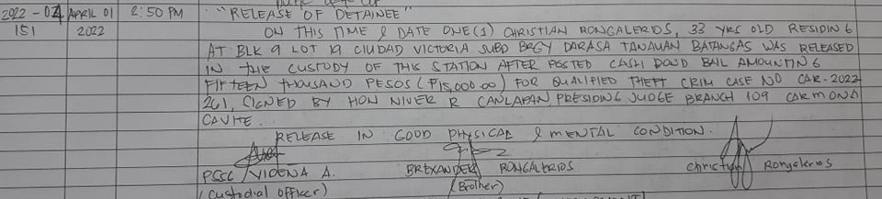

2022-04-154

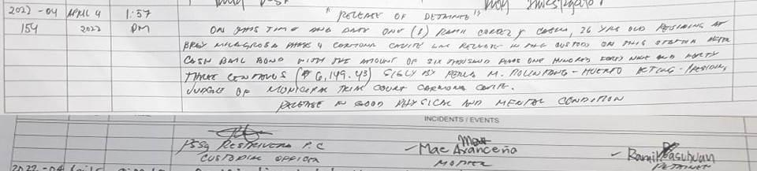

2022-04-157

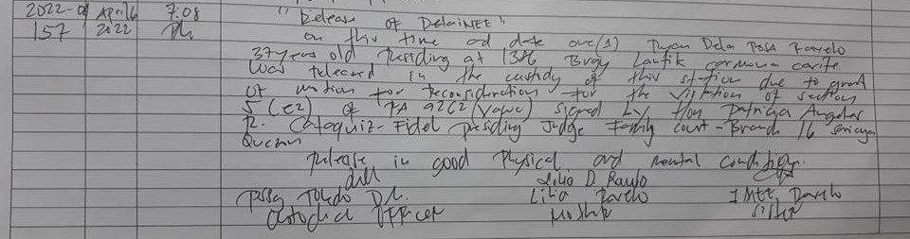

2022-04-164

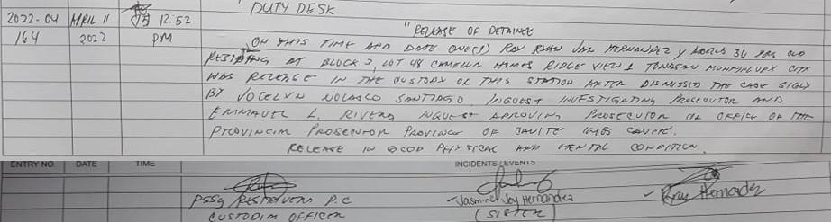

2022-04-165

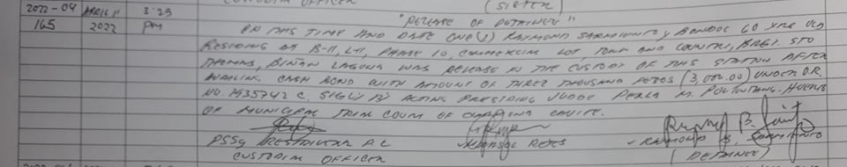

2022-04-166

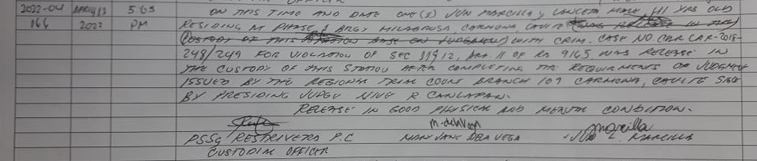

2022-04-169

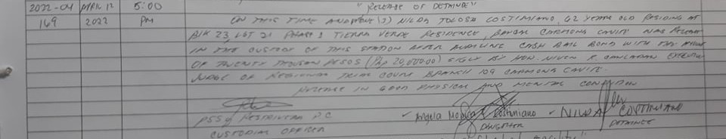

2022-04-178

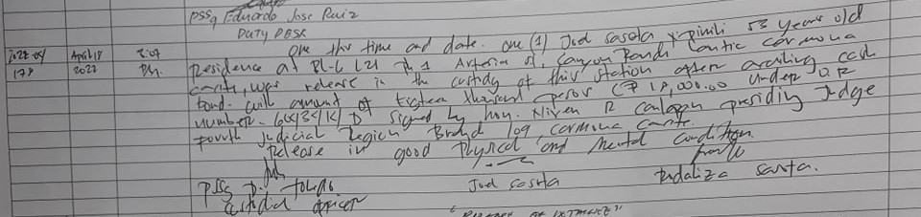

2022-04-179

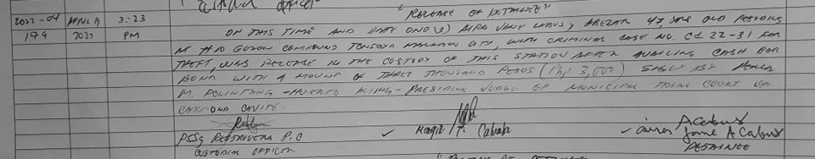

2022-04-180

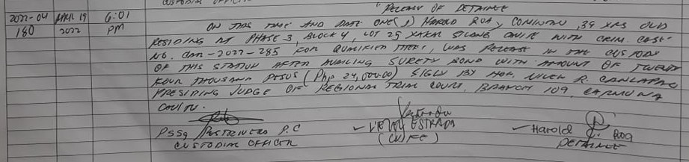

2022-04-192

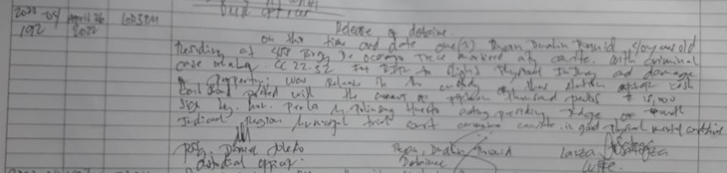

2022-04-195

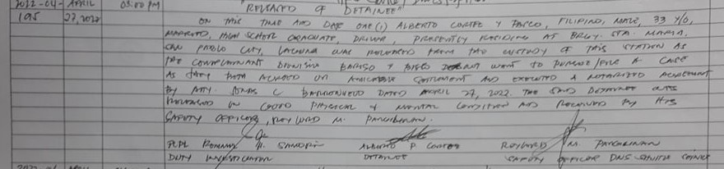

2022-04-196

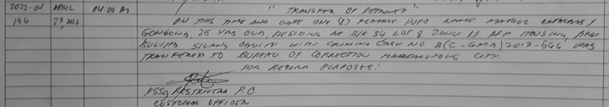

2022-04-197

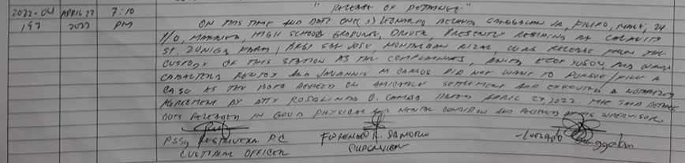

2022-04-200

